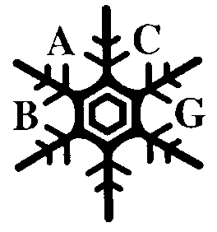
B A C G

British Association for Crystal Growth

Registered Charity No. 261780

BACG ANNUAL GENERAL MEETING ON WEDNESDAY 20TH JUNE 2018 5.45 pm Room AD2-010 UNIVERSITY OF LIMERICK

AGENDA

- Minutes of the AGM held on 28th June 2017 at Manchester.

- Matters arising
- Chairman’s report Joop Ter Horst
- Treasurer’s report Ghazala Sadiq
- Membership Secretary’s report Ming Zhong Li
- Election of Officers Linda Seton
- Date of next meeting
- Any other business

Linda Seton
Secretary

